NAME:P S DARSAN VIKKAS

CLASS: B-TECH IT (III YR)

DATE: 06/08/2024 – 10/08/2024

GIT REPOSITORY: https://github.com/DARSAN-VIKKAS37/

**MICROSOFT AZURE**

|  |  |  |
| --- | --- | --- |
| **MODULE** | **DESCRIPTION** | **PAGE NUMBER** |
| 1 | CREATION OF VIRTUAL MACHINE | 2 |
| 2 | CONFIGURE GIT WITH NETWORK | 2 |
| 3 | CREATION OF STORAGE ACCOUNT | 9 |
| 4 | CREATION OF STATIC WEB APPS | 10 |

**MODULE 1: CREATION OF VIRTUAL MACHINE**

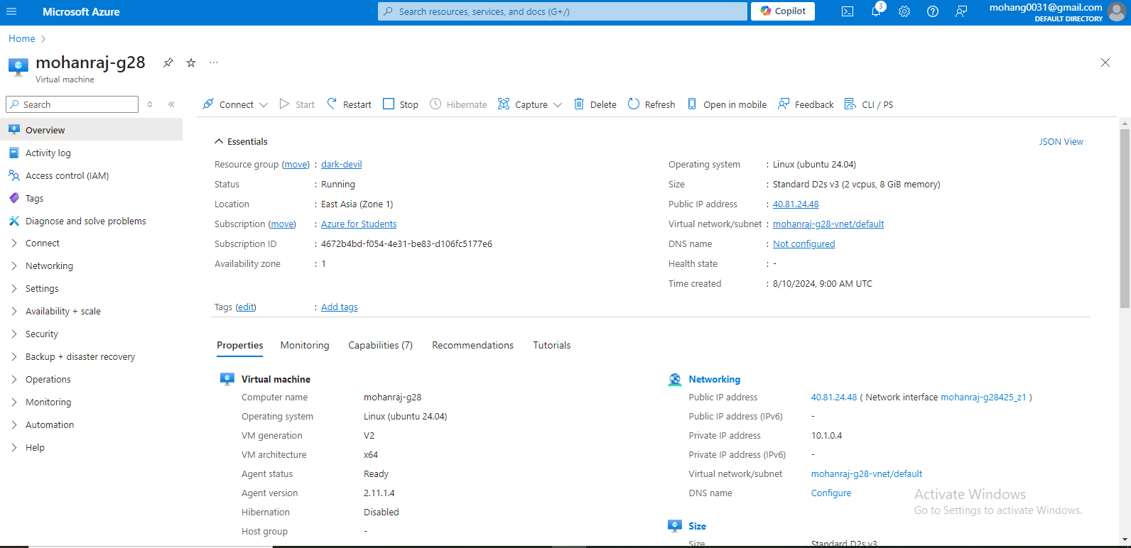

**MODULE 2: CONFIGURE GIT WITH NETWORK**

Requesting a Cloud Shell.Succeeded.

Connecting terminal...

Your Cloud Shell session will be ephemeral so no files or system changes will persist beyond your current session.

PS /home/mohan> ssh Nishore@104.214.172.113

mohan@104.214.172.113's password:

Welcome to Ubuntu 24.04 LTS (GNU/Linux 6.8.0-1012-azure x86_64)

* Documentation: https://help.ubuntu.com

* Management: https://landscape.canonical.com

* Support: https://ubuntu.com/pro

System information as of Sat Aug 10 08:28:18 UTC 2024

System load: 0.12 Processes: 133

Usage of /: 5.0% of 28.02GB Users logged in: 0

Memory usage: 3% IPv4 address for eth0: 10.0.0.4

Swap usage: 0%

* Strictly confined Kubernetes makes edge and IoT secure. Learn how MicroK8s

just raised the bar for easy, resilient and secure K8s cluster deployment.

https://ubuntu.com/engage/secure-kubernetes-at-the-edge

Expanded Security Maintenance for Applications is not enabled.

0 updates can be applied immediately.

Enable ESM Apps to receive additional future security updates.

See https://ubuntu.com/esm or run: sudo pro status

The programs included with the Ubuntu system are free software;

the exact distribution terms for each program are described in the

individual files in /usr/share/doc/*/copyright.

Ubuntu comes with ABSOLUTELY NO WARRANTY, to the extent permitted by

applicable law.

To run a command as administrator (user "root"), use "sudo <command>".

See "man sudo_root" for details.

Mohanraj_g28:~$ sudo apt update

Hit:1 http://azure.archive.ubuntu.com/ubuntu noble InRelease

Get:2 http://azure.archive.ubuntu.com/ubuntu noble-updates InRelease [126 kB]

Get:3 http://azure.archive.ubuntu.com/ubuntu noble-backports InRelease [126 kB]

Hit:4 http://azure.archive.ubuntu.com/ubuntu noble-security InRelease

Get:5 http://azure.archive.ubuntu.com/ubuntu noble/universe amd64 Packages [15.0 MB]

Get:6 http://azure.archive.ubuntu.com/ubuntu noble/universe Translation-en [5982 kB]

Get:7 http://azure.archive.ubuntu.com/ubuntu noble/universe amd64 Components [3871 kB]

Get:8 http://azure.archive.ubuntu.com/ubuntu noble/universe amd64 c-n-f Metadata [301 kB]

Get:9 http://azure.archive.ubuntu.com/ubuntu noble/multiverse amd64 Packages [269 kB]

Get:10 http://azure.archive.ubuntu.com/ubuntu noble/multiverse Translation-en [118 kB]

Get:11 http://azure.archive.ubuntu.com/ubuntu noble/multiverse amd64 Components [35.0 kB]

Get:12 http://azure.archive.ubuntu.com/ubuntu noble/multiverse amd64 c-n-f Metadata [8328 B]

Get:13 http://azure.archive.ubuntu.com/ubuntu noble-updates/main amd64 Packages [344 kB]

Get:14 http://azure.archive.ubuntu.com/ubuntu noble-updates/universe amd64 Packages [321 kB]

Get:15 http://azure.archive.ubuntu.com/ubuntu noble-updates/universe Translation-en [135 kB]

Get:16 http://azure.archive.ubuntu.com/ubuntu noble-updates/universe amd64 Components [45.0 kB]

Get:17 http://azure.archive.ubuntu.com/ubuntu noble-updates/universe amd64 c-n-f Metadata [12.7 kB]

Get:18 http://azure.archive.ubuntu.com/ubuntu noble-updates/multiverse amd64 Packages [14.1 kB]

Get:19 http://azure.archive.ubuntu.com/ubuntu noble-updates/multiverse Translation-en [3608 B]

Get:20 http://azure.archive.ubuntu.com/ubuntu noble-updates/multiverse amd64 Components [212 B]

Get:21 http://azure.archive.ubuntu.com/ubuntu noble-updates/multiverse amd64 c-n-f Metadata [532 B]

Get:22 http://azure.archive.ubuntu.com/ubuntu noble-backports/main amd64 Components [208 B]

Get:23 http://azure.archive.ubuntu.com/ubuntu noble-backports/main amd64 c-n-f Metadata [112 B]

Get:24 http://azure.archive.ubuntu.com/ubuntu noble-backports/universe amd64 Packages [10.3 kB]

Get:25 http://azure.archive.ubuntu.com/ubuntu noble-backports/universe Translation-en [10.5 kB]

Get:26 http://azure.archive.ubuntu.com/ubuntu noble-backports/universe amd64 Components [17.6 kB]

Get:27 http://azure.archive.ubuntu.com/ubuntu noble-backports/universe amd64 c-n-f Metadata [1016 B]

Get:28 http://azure.archive.ubuntu.com/ubuntu noble-backports/restricted amd64 Components [216 B]

Get:29 http://azure.archive.ubuntu.com/ubuntu noble-backports/restricted amd64 c-n-f Metadata [116 B]

Get:30 http://azure.archive.ubuntu.com/ubuntu noble-backports/multiverse amd64 Components [212 B]

Get:31 http://azure.archive.ubuntu.com/ubuntu noble-backports/multiverse amd64 c-n-f Metadata [116 B]

Get:32 http://azure.archive.ubuntu.com/ubuntu noble-security/universe amd64 Packages [249 kB]

Get:33 http://azure.archive.ubuntu.com/ubuntu noble-security/universe Translation-en [108 kB]

Get:34 http://azure.archive.ubuntu.com/ubuntu noble-security/universe amd64 Components [8632 B]

Get:35 http://azure.archive.ubuntu.com/ubuntu noble-security/universe amd64 c-n-f Metadata [9376 B]

Get:36 http://azure.archive.ubuntu.com/ubuntu noble-security/multiverse amd64 Packages [10.6 kB]

Get:37 http://azure.archive.ubuntu.com/ubuntu noble-security/multiverse Translation-en [2808 B]

Get:38 http://azure.archive.ubuntu.com/ubuntu noble-security/multiverse amd64 Components [208 B]

Get:39 http://azure.archive.ubuntu.com/ubuntu noble-security/multiverse amd64 c-n-f Metadata [344 B]

Fetched 27.2 MB in 5s (5140 kB/s)

Reading package lists... Done

Building dependency tree... Done

Reading state information... Done

All packages are up to date.

Mohanraj-g28:~$ sudo apt install git

Reading package lists... Done

Building dependency tree... Done

Reading state information... Done

git is already the newest version (1:2.43.0-1ubuntu7.1).

git set to manually installed.

0 upgraded, 0 newly installed, 0 to remove and 0 not upgraded.

Mohanraj_g28:~$ sudo apt install nginx

Reading package lists... Done

Building dependency tree... Done

Reading state information... Done

The following additional packages will be installed:

nginx-common

Suggested packages:

fcgiwrap nginx-doc ssl-cert

The following NEW packages will be installed:

nginx nginx-common

0 upgraded, 2 newly installed, 0 to remove and 0 not upgraded.

Need to get 552 kB of archives.

After this operation, 1596 kB of additional disk space will be used.

Do you want to continue? [Y/n] y

Get:1 http://azure.archive.ubuntu.com/ubuntu noble/main amd64 nginx-common all 1.24.0-2ubuntu7 [31.2 kB]

Get:2 http://azure.archive.ubuntu.com/ubuntu noble/main amd64 nginx amd64 1.24.0-2ubuntu7 [521 kB]

Fetched 552 kB in 0s (17.0 MB/s)

Preconfiguring packages ...

Selecting previously unselected package nginx-common.

(Reading database ... 64525 files and directories currently installed.)

Preparing to unpack .../nginx-common_1.24.0-2ubuntu7_all.deb ...

Unpacking nginx-common (1.24.0-2ubuntu7) ...

Selecting previously unselected package nginx.

Preparing to unpack .../nginx_1.24.0-2ubuntu7_amd64.deb ...

Unpacking nginx (1.24.0-2ubuntu7) ...

Setting up nginx (1.24.0-2ubuntu7) ...

Setting up nginx-common (1.24.0-2ubuntu7) ...

debconf: unable to initialize frontend: Dialog

debconf: (Dialog frontend requires a screen at least 13 lines tall and 31 columns wide.)

debconf: falling back to frontend: Readline

Created symlink /etc/systemd/system/multi-user.target.wants/nginx.service → /usr/lib/systemd/system/nginx.service.

Processing triggers for ufw (0.36.2-6) ...

Processing triggers for man-db (2.12.0-4build2) ...

Scanning processes...

Scanning linux images...

Running kernel seems to be up-to-date.

No services need to be restarted.

No containers need to be restarted.

No user sessions are running outdated binaries.

No VM guests are running outdated hypervisor (qemu) binaries on this host.

Mohanraj_g28:~$ sudo systemctl start nginx

Mohanraj_g28:~$ sudo systemctl enable nginx

Synchronizing state of nginx.service with SysV service script with /usr/lib/systemd/systemd-sysv-install.

Executing: /usr/lib/systemd/systemd-sysv-install enable nginx

Mohanraj_g28:~$ cd /var/www/html

Mohanraj_g28:/var/www/html$ sudo rm -rf *

Mohanraj_g28:/var/www/html$ sudo git clone https://github.com/Nishore-N/Portfolio.git .

Cloning into '.'...

remote: Enumerating objects: 118, done.

remote: Counting objects: 100% (118/118), done.

remote: Compressing objects: 100% (112/112), done.

remote: Total 118 (delta 6), reused 0 (delta 0), pack-reused 0

Receiving objects: 100% (118/118), 4.03 MiB | 5.83 MiB/s, done.

Resolving deltas: 100% (6/6), done.

Mohanraj_g28:/var/www/html$ sudo chown -R www-data:www-data /var/www/html

Mohanraj_g28:/var/www/html$

**OUTPUT:**

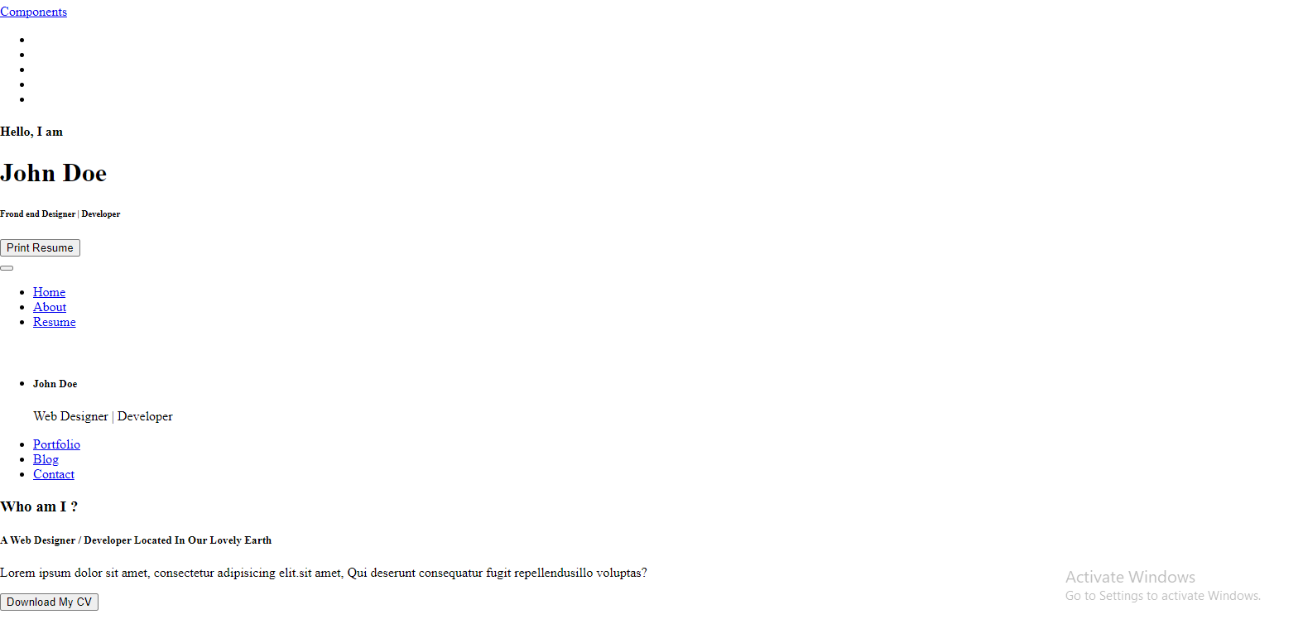

**MODULE 3: CREATION OF STATIC WEB APPS**

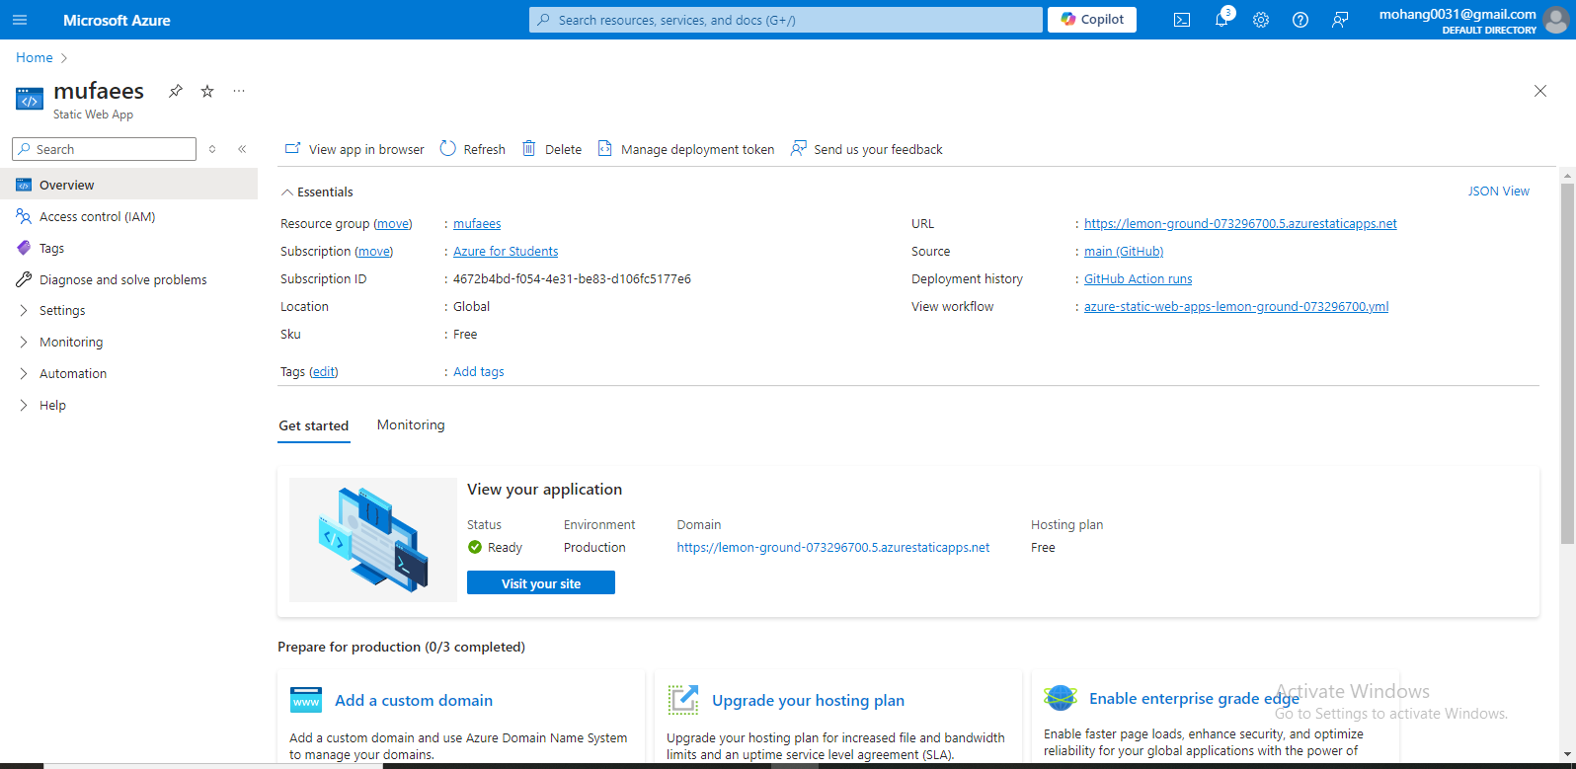

https://witty-forest-0fb067200.5 aturestaticoppio.net

OUTPUT:

